**PENTAGON’S HAMMER**

(Fiction Novel by Lester T. Randall)

# FACT

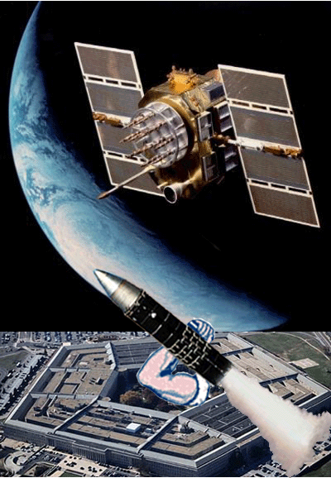

Pentagon’s Hammer is a fictional novel about intrigue, conspiracy, and deception in the Intelligence community, which is manipulated by world power brokers. Where seventy-five percent of events have already occurred, the remaining fictional accounts will take place in the near future, by which time, fiction turns into reality. Despite national security safeguards, it is only a matter of time for future events as described in this book to come to pass. The contents of this novel shall serve as warning to nations with intentions for causing harm to the people of the United States and its allies.

# PREFACE

It is too late to save one million American lives but it could have been worse. The adversary’s intent was to annihilate the entire American nation including all its inhabitants. But due to the diligence of the many dedicated individuals working within the U.S. defense grid the collateral damage was held at a minimum.

One million casualties and greater is not new to mankind. Man has lost many more souls over the ages through war, disease and famine. We thought with the age of science and technology a disaster as described herein could have been prevented but accounts described prove otherwise. Even though the 911 attack was devastating to the nation, it was only a warning for bigger things to come.

With the end of the cold war, major threats from nuclear attack diminished, so we thought. The Pentagon’s Hammer incidence proves otherwise. Because of what we are, mankind will never be at peace for very long. While many nations continue to strive for lasting peace, others will never align. Struggle for survival will continue as has been for eons. Where one nation fights for more space, others will for ideology, but worst yet, fighting for religious causes. Americans living in a democratic nation have learned to live side-by-side with the many religions. We have proven that many factions can coexist with each other.

The reason our democratic nation has been successful is for a simple rule: keeping State separated from Church. Where the state is run by government and politicians it is not greatly influenced by religious orders. It is our choice to live in a paradigm based on the principle from freedom of speech and liberty of movement founded by our forefathers.

Contemptuous nations should study the constitution of the United States to learn what it takes to coexist among many diversified faiths and cultures. There was a strong reason why this constitution was created. After all, its designers escaped persecutions from predominantly religious factions themselves. We can only hope to control acts of aggression through the help of science and technology with the cooperation of other likeminded nations. A nation’s people, culture, and boarders are important for the preservation of identity regardless of political structure. There may come a time when all nations unite for a global government with the purpose in mind of effectively managing crime and aggression, but in the process will lose their identity.

It is important to protect the nation’s boarders even though it may cause the occasional conflict. As with crime, terrorism is expanding with population growth. It is here to stay. The only recourse we have is to manage its means effectively. With the expanding threats, entire new industries have been created demanding great resources in manpower and cost but the cost of freedom is high. To keep this freedom, we all have to share an ever growing awareness for the preservation of the free world. After all, we have vast regions of space open to explore and populate.

Where public awareness does not generally include national Intelligence knowledge, Pentagon’s Hammer demonstrates all the elements needed to effectively manage the defense system. There are many pieces needed to accomplish that objective. Some of these include satellite communications, organizational procedures, interoperability for a common picture, emergency plans, personal dedication, and design specifics in science and technology for nuclear, computer, and communication systems.

Organizational readiness is the nation’s highest objective for warding off terrorism, hostile confrontations, and crime on humanity but cannot always completely assure success. In cases of emergencies, crisis management will take over to resolve a situation whether from natural cause, hostile cause, or radical Islamic factions.

# BACK COVER

Department of Defense analyst Alex Bauer had the foreboding for protecting the nation from what may have turned into a national holocaust. Due to his intricate knowledge of U.S. intelligence networks and diligence in analyzing world events, a major catastrophe was diverted to only a local incidence. What triggered his suspicion was a group of ASATs (attack satellites) changing orbital paths to position for an all out assault on the American communications system through EMP pulsing. The resultant nuclear confrontation ended with strike and counterstrike between two adversary nations. With the help of his daughter Tracy (NSA strategist), friend Brian Harris, and a team of organizational experts from NORAD and SPACECOM, an Al Qaeda coordinated terrorist plot was minimized. Pentagon’s Hammer takes the reader through a journey into intelligence organizations and in the process gain in-depth knowledge into the workings of the U.S. defense system.

**DISCLAIMER**

Following extensive research into previously published material on the subject of intelligence, the author came to the conclusion there is no comprehensive work describing the complexity of each agency within the intelligence community. Due to intricate knowledge obtained working as systems analyst on a number of classified projects, as well as in designs for nuclear protection, the author gained the skills and expertise necessary for compiling comprehensive information into a meaningful work of fiction.

It is not the intention of the author to disclose classified information detrimental to national security. Information contained in this writing has been declassified and is public knowledge through the Freedom of Information Act. Even though this book is based on non-fictional intelligence, all characters are fictional in nature. The main purpose is to demonstrate to the public some of the policies and internal processes within the defense system in case of nuclear confrontation or other national emergency.

# DATA SOURCES

Where the author is knowledgeable in detailed aspects for organizations, science, and technology illustrated in Pentagon’s Hammer, verification for technical specifications came from data sources using Internet Web Crawlers, Internet Spiders, Google Browser, and Wikipedia Encyclopedia (largest multilingual free-content encyclopedia on the Internet.) With the development of the Internet, information access on almost every facet of life is available at the fingertip. However, putting all into perspective to form an intelligent picture requires thorough understanding on a more comprehensive scale.

The advantage an author has in research using the Internet over libraries and archives is speed but does not exclude individual knowledge on information contained in inaccessible Intel organizational databases. Intelligence agencies are very protective of their sensitive information for distinctive reasons: to protect the nation and its population from others and themselves. Where everybody has a personal opinion on how to manage politics and diplomacy, it takes specialists to execute policies and procedures. It is up to us for choosing the most qualified individuals from local functionaries to the highest office in the Capital to represent each and every one of us for creating a safer nation.

To gain thorough understanding in all phases of ideology, politics, customs, and cultures as described herein, the author is providing specific details on the various topics not normally provided with a fiction novel. This includes a wealth of intellectual properties stored in the many distributed databases compiled by respective specialists otherwise unobtainable to the general population. Making use of the tools available through the Internet provides the information needed for completing the common picture for everyone to appreciate and enjoy.

It may seem dry reading for some, interesting to others, but necessary for the reader of free nations to thoroughly appreciate the democratic effort the United States is trying to promote. Free democracy may not be the ideal doctrine for all nations but is the best proven policy this country can offer for the preservation of resources and well-being of mankind.

In conclusion, getting comprehensive knowledge to the reader, the author provides detailed technical data, historical accounts, and military directives to seamlessly merge the many different segments illustrated throughout the chapters. It is the author’s desire to inform the reader of potential threats by adversary nations through possibly mass destruction to this nation and its population taking advantage of weaknesses and vulnerabilities created by the lack of cooperation. We must become aware of such flaws by demonstrating individual diligence in identifying these weaknesses in infrastructure, boarders, and social order from undesirable subjects by becoming cognizant and sensitive to abnormal behavior.

tlr